First Vice-Chair:  Laurie Slade Funderburk  Katherine E. (Katie) Arrington  Gary E. Clary  MaryGail K. Douglas  Phyllis J. Henderson  Joseph H. Jefferson Jr.  Mandy Powers Norrell  J. Todd Rutherford  Tommy M. Stringer  Bill Taylor  Jennifer L. Dobson  Research Director  Cathy A. Greer  Administration Coordinator | Chair Wm. Weston J. Newton  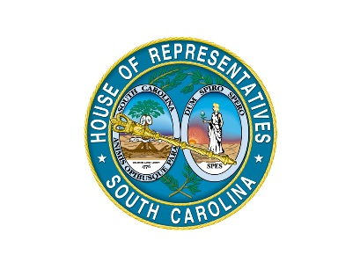  Legislative Oversight Committee  South Carolina House of Representatives  Post Office Box 11867  Columbia, South Carolina 29211  Telephone: (803) 212-6810 • Fax: (803) 212-6811  Room 228 Blatt Building | William K. (Bill) Bowers  Neal Collins  Raye Felder  William M. “Bill” Hixon  Robert L. Ridgeway III  James E. Smith Jr.  Edward R. Tallon Sr.  Robert Q. Williams  Charles L. Appleby IV  Legal Counsel  Carmen J. McCutcheon Simon  Research Analyst/Auditor

Education and Cultural Subcommittee
October 4, 2017
Archived Video Available
- Pursuant to House Legislative Oversight Committee Rule 6.8, South Carolina ETV was allowed access for streaming the meeting. You may access an archived video of this meeting by visiting the South Carolina General Assembly’s website (http://www.scstatehouse.gov) and clicking on Committee Postings and Reports, then under House Standing Committees click on Legislative Oversight. Then, click on Video Archives for a listing of archived videos for the Committee.
Attendance
- The Education and Cultural Subcommittee meeting was called to order by Chair James E. Smith, Jr., on Wednesday, October 4, 2017, in Room 110 of the Blatt Building. All members were present for some or all of the meeting, except Representative Tommy M. Stringer and Representative Felder.
Minutes
- House Rule 4.5 requires standing committees to prepare and make available to the public the minutes of committee meetings, but the minutes do not have to be verbatim accounts of meetings. It is the practice of the Legislative Oversight Committee to provide minutes for its subcommittee meetings.
- There was not a quorum present, so no motions were considered.

Discussion of John de la Howe School.
- Chairman Smith called the meeting to order and stated that this is the subcommittee’s first meeting with John de la Howe.

- Chairman Smith swears in the following individuals:
  - James A. Franklin, Interim Superintendent, John de la Howe School
  - Zebulon Young, Director of Human Resources, John de la Howe School
  - Sylvester Coleman, Director of Finance and Business Operations, John de la Howe School
  - Jonathon Rose, Director of Education, John de la Howe School
  - Daniel Wardlaw, Director of Student and Family Services, John de la Howe School

- Chairman Smith explained that the purpose of the meeting is to hear testimony from different representatives of John de la Howe School about the history, business operations, and student and family services.

- Dr. Franklin provides testimony about the following:
  - Introduces John de la Howe
  - Shows aerial video tour of the school

- Dr. Young provides testimony about the following:
  - History
  - Organization of the Human Resources department

- Mr. Coleman provides testimony about the following:
  - Agriculture Deliverables
  - Finance and Business Operations

- Mr. Rose provides testimony about the following:
  - Mechanical Training
  - Education Challenges

Mr. Wardlaw provides testimony about the following:
  - Family and Student Outreach Process
  - Residential Process

- Members asked questions, which different agency representative answered. Question topics include:
  - Board Vacancies
  - Full Time Employees
  - Graduation Rates
  - Food Cost
- There being no further business, the meeting was adjourned.

